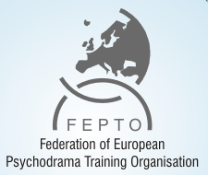

Modulo di iscrizione a “Disorder specific Interventions in Psychodrama Therapy with children and youth”
Torino, 02.02 - 04.02.2017
(inviare: angela.sordano@gmail.com e feptochildren2018@gmail.com entro 15 Dicembre 2017)

__________________________________________________________________________________________________
nome e cognome

_____________________________________________________________________________________________________________
posizione

____________________________________________________________________________________________________________
Istituzione

____________________________________________________________________________________________________________
telefono e fax

_____________________________________________________________________________________________________________
e-mail

Proposta workshop: si □ no □

_____________________________________________________________________________________________________________
Titolo workshop

Breve abstract:
_____________________________________________________________________________________________________________

_____________________________________________________________________________________________________________

_____________________________________________________________________________________________________________

_____________________________________________________________________________________________________________

_____________________________________________________________________________________________________________

Sottolineiamo che l’evento è gratuito, tuttavia si chiede gentilmente un’integrazione di 10€ per il coffee break, da versare sul conto corrente IT 33 N 02008 01055 000005113304, intestato all'Associazione Ricerca e Formazione Psicoterapia, contestualmente al modulo di iscrizione.

Autorizzo il trattamento dei miei dati personali ai sensi del Decreto Legislativo 196/2003

Data ___________________________ Firma ______________________________

